2010 H2 CHEMISTRY PRELIMINARY EXAMINATION PAPER 2 ANSWERS

1(a)(i)
2NaOH(aq) + H₂SO₄(aq) → Na₂SO₄(aq) + 2H₂O(l)

(ii)
NaOH(aq) + CH₃CO₂H(l) → CH₃CO₂–Na⁺(aq) + H₂O(l)

(b)
Step 1: Using a measuring cylinder, add 30 cm³ of FA1 into the polystyrene cup provided and record its initial temperature. Using another measuring cylinder, measure 60 cm³ of 1.00 mol dm^{–3} NaOH and record its initial temperature.

Step 2: Add the 60 cm³ of 1.00 mol dm^{–3} NaOH into the polystyrene cup containing FA1, stir with the thermometer and record the highest temperature reached. Rinse the cup.

Step 3: Repeat steps 1 and 2, this time replacing FA1 with FA2.

[Accept any specific volume suggested by student.]

(c)
No of moles of NaOH(aq) used = 1.0 x 60/1000 = 0.060 mol

For 1.00 mol dm^{–3} CH₃CO₂H, no of moles of H₂O formed
= 1.00 x 30/1000
= 0.030 mol

For 1.00 mol dm^{–3} H₂SO₄, no of moles of H₂O formed
= 2 x 1.00 x 30/1000
= 0.060 mol

Since number of moles of water formed in the two reactions are in the ratio of 1:2, temperature change for the two reactions is expected to be around 1:2.

If ΔT₂ = 2ΔT₁, FA2 is H₂SO₄ and FA1 is CH₃CO₂H.

[Other methods are acceptable.]
[4 m; award according to the method used]

(d)
Due to electron withdrawing inductive effect of chlorine,
the negative charge on CHCl₂CO₂– is more dispersed than that of CH₃CO₂–,
resulting in greater stability for CHCl₂CO₂–.
Hence, CHCl₂CO₂H is a stronger acid than CH₃CO₂H and
the enthalpy change of reaction per mole of CHCl₂CO₂H is more exothermic than that for CH₃CO₂H.

(e)
Titration between H₂SO₄ and NaOH: phenolphthalein or methyl orange
Titration between CH₃CO₂H and NaOH: phenolphthalein

(f)
Both acids are monobasic.
Thus, the volume of NaOH(aq) required is the same for both acids.

2(a)(i)
MgCl₂ has ionic bonding between Mg²⁺ and Cl– ions.
AlCl₃ has dispersion forces between the molecules.
More energy is needed
to break the stronger ionic bonding in MgCl₂ leading to its higher melting point.

(ii)
When MgCl₂ reacts with water, pH of solution formed is 6.5.
MgCl₂ + H₂O ⇌ Mg(OH)Cl + HCl
When AlCl₃ reacts with water, pH of solution formed is 3.
Al(H₂O)₆³⁺ + H₂O ⇌ Al(H₂O)₅(OH)²⁺ + H₃O⁺

(iii)
MgO reacts slowly with water
to form a solution of pH 8 (accept 8–9).
MgO + H₂O ⇌ Mg(OH)₂
BaO reacts readily with water
to form a solution of pH 12.
BaO + H₂O → Ba(OH)₂

(iv)(I)
Ga₂O₃ + 2NaOH + 3H₂O → 2Na[Ga(OH)₄]
As₂O₃ + 6NaOH → 2Na₃AsO₃ + 3H₂O

(II)
Ga₂O₃ + 6HCl → 2GaCl₃ + 3H₂O

(b)(i)
1s² 2s² 2p⁶ 3s² 3p⁴

(ii)
E is sulfur.
First I.E. of E is lower than that of D as less energy is required to remove the 3p⁴ electron which experiences interelectronic repulsion.

(c)(i)
ΔG_{f}º = ΔH_{f}º – TΔS_{f}º ⇒ ΔS_{f}º = (ΔH_{f}º – ΔG_{f}º) / T
ΔS_{f}º(SO₂) = [–296.8 – (–300.2)] / 298 = 0.0114 kJ mol^{–1} K^{–1} = 11.4 J mol^{–1} K^{–1}
ΔS_{f}º(SO₃) = [–395.7 – (–371.1)] / 298 = –0.0826 kJ mol^{–1} K^{–1} = –82.6 J mol^{–1} K^{–1}

(ii)
ΔS_{r}º > 0 as there are more gaseous products than gaseous molecules.
ΔG_{r}º < 0 as ΔH_{r}º < 0 and ΔS_{r}º > 0. Hence, the reaction is feasible at all temperatures.

3(a)(i)
Heat evolved
= 200 x 4.18 x 46.9 x 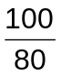 [–½ m if missing 100/80]
= 49000 J or 49.0 kJ

Amount of cyclobutane used
= 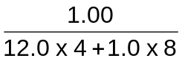
= 0.0179 mol

ΔH_{c}(cyclobutane)
= –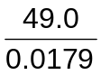
= –2740 kJ mol^{–1}
[½ m for sign and unit. Ignore wrong computation, allow ecf.]

(ii)
ΔH₁ = ΔH_{c}(cyclobutane) – 2ΔH_{c}(CH₂=CH₂)
= –2740 – 2(−1422) (ecf)
= +104 kJ mol^{–1}

(b)(i)
H₃PO₄ or concentrated H₂SO₄

(ii)
The heat change when one mole of ethanol is formed from its constituent elements in their standard states at 298 K and 1 atm.
2C(s) + 3H₂(g) + ½O₂(g) → CH₃CH₂OH(l)

(iii)
ΔH = ΣBE(reactants) – ΣBE(products)
= 3(436) + ½(496) – (350 + 5 x 410 + 360 + 460)
= –1664 kJ mol^{–1}

(iv)
2C(g) + 3H₂(g) + ½O₂(g) CH₃CH₂OH(g)
–1664
+39
2C(s) + 3H₂(g) + ½O₂(g) CH₃CH₂OH(l)
2ΔH_{at}
–276
By Hess’ Law,
2ΔH_{at} = –276 + 39 – (–1664)
= +1427 kJ
ΔH_{at} = +713.5 kJ mol^{–1}

(c)(i)
Step 1: H⁺ / K₂Cr₂O₇, distil
Step 2: HCN, NaCN catalyst, room temperature

(ii)
CH₃CHClCOCl

(iii)
H₂NCH₂CH₂NH₂, heat in a sealed tube or high temperature and pressure

4(a)(i)
Reagent: alkaline aqueous I₂
Condition: warm (< 70 ºC)
Observation: Yellow ppt (CHI₃) formed for 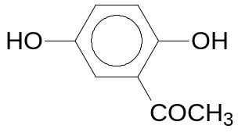 and no yellow ppt formed for 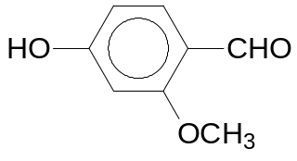.
[OR Tollen’s reagent, heat, Ag mirror formed for benzaldehyde only (no reaction with Fehling’s solution)]

(ii)
Step 1:
Reagent: NaOH(aq)
Condition: heat

CH₃CONHCH₃ gives CH₃CO₂–Na⁺ and CH₃NH₂.
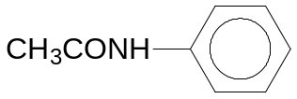 gives CH₃CO₂–Na⁺ and C₆H₅NH₂.

Step 2:
Reagent: Br₂(aq)
Condition: room temperature

C₆H₅NH₂ decolourises brown Br₂(aq) with formation of white ppt. No such observations for CH₃NH₂.

(b)(i)
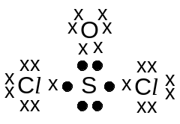

(ii)
107º

(iii)
SOCl₂ + H₂O → SO₂ + 2HCl

(iv)
CH₃OH molecules are held by hydrogen bonding.
SOCl₂ molecules are held by dipole–dipole interactions.
SOCl₂ molecules have more electrons than CH₃OH molecules.
Thus, dispersion forces between SOCl₂ molecules are stronger than hydrogen bonding between CH₃OH molecules.
More energy is needed to overcome the dispersion forces in SOCl₂ leading to its higher boiling point.

(c)(i)
K_{sp} = [Ag⁺][Cl–] = 1.8 x 10^{–10}

Let s be the solubility of AgCl in the given AgNO₃ solution.
(s + 5.0 x 10^{–3})(s) = 1.8 x 10^{–10}
Assume s << 5.0 x 10^{–3},
s = 3.6 x 10^{–8} mol dm^{–3}

Maximum mass of AgCl that could dissolve
= 3.6 x 10^{–8} x 0.300 x 143.5
= 1.55 x 10^{–6} g

(ii)
AgCl(s) ⇌ Ag⁺(aq) + Cl–(aq)
Ag⁺(aq) from AgNO₃
caused the above equilibrium to shift left by Le Chatelier’s Principle.
Thus, the solubility of AgCl is suppressed due to common ion effect.

(iii)
AgCl(s) ⇌ Ag⁺(aq) + Cl–(aq)
S₂O₃^{2–} forms a complex with Ag⁺.
This decreases [Ag⁺].
Hence, the above equilibrium shifts right which causes more AgCl to dissolve.
5(a)(i)
Element | C | H | O
% by mass | 63.2 | 8.7 | 28.1
No. of moles | 63.2 / 12.0  = 5.27 | 8.7 / 1.0  = 8.7 | 28.1 / 16.0  = 1.76
Mole ratio | 3 | 5 | 1

Empirical formula of X is C₃H₅O.

(ii)
No. of moles of Br₂ = 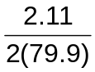 = 0.0132 mol
M_{r} of X = 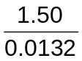 = 113.6

(iii)
Let the molecular formula of X be (C₃H₅O)_{n}.
(3 x 12.0 + 5 x 1.0 + 16.0)n = 113.6
n = 2
Molecular formula of X is C₆H₁₀O₂.

(iv)
CH₂=CHCH(CH₂CH₃)CO₂H
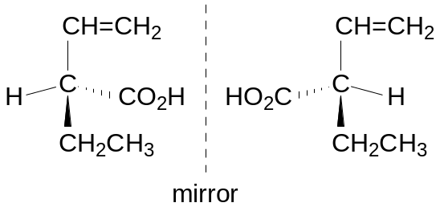

(b)(i)
Acidity decreases in the order: CH₃CO₂H > C₆H₅OH > CH₃CH₂OH.
Stability of ion decreases in the order: CH₃CO₂– > C₆H₅O– > CH₃CH₂O–.
CH₃CO₂H is the strongest acid as the CH₃CO₂– ion is resonance–stabilised (OR stabilised to a greater extent by delocalisation of the negative charge over the C and 2 O atoms).
C₆H₅OH is a stronger acid than CH₃CH₂OH as the C₆H₅O– ion is more stabilised due to the delocalisation of the negative charge into the benzene ring.
The CH₃CH₂O– ion is destabilised as the negative charge is intensified by the electron–donating inductive effect of the ethyl group.

(ii)
pK_{b} decreases in the order: CH₃CO₂– > C₆H₅O– > CH₃CH₂O–.

(iii)
–lg [H⁺] = 5.0
[H⁺] = 1.0 x 10^{–5} mol dm^{–3}
K_{a} = 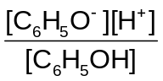
10^{–9.95} = (1.0 x10^{–5})² / [C₆H₅OH]
[C₆H₅OH] = 0.891 mol dm^{–3}

Solubility of C₆H₅OH = 0.891 mol dm^{–3}

(c)(i)
 | Tube 1 | Tube 2 | Tube 3
Compound | C | A | B

(ii)
C₆H₅COCl undergoes hydrolysis more readily than C₆H₅CH₂Br as the carbonyl carbon atom is more electron deficient due to two electronegative atoms (O and Cl).

C₆H₅I has no reaction because the C–I bond is strengthened (OR has partial double bond character) by the overlapping of the p orbital of I with the π orbitals of the benzene ring.

(iii)
Time taken would be longer (than 10 seconds).

C₆H₅CH₂Cl undergoes hydrolysis less readily than C₆H₅CH₂Br as the C–Cl bond is stronger (OR BE(C–Cl) > BE(C–Br)).

